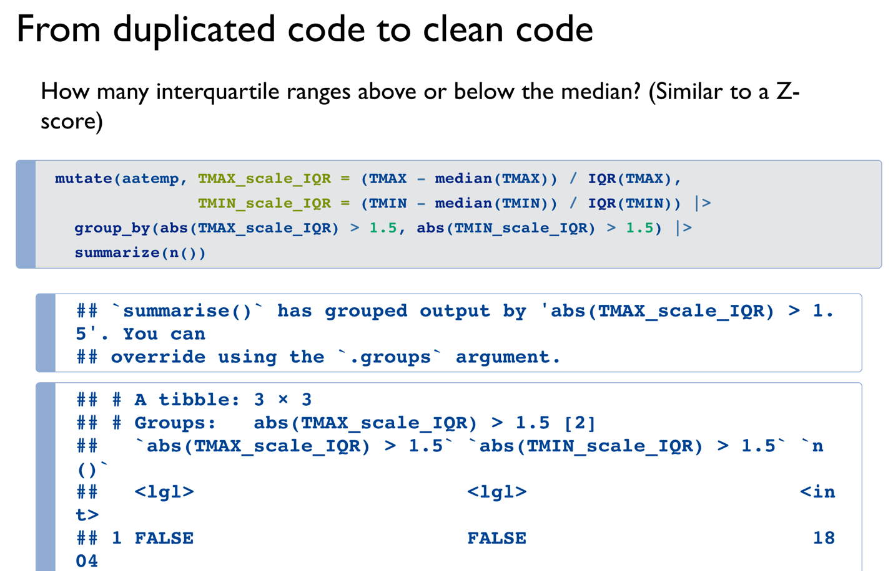

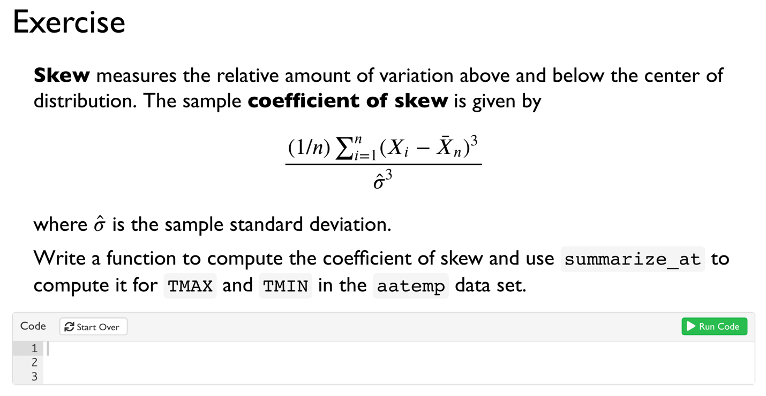

Then R for DS 7-7.8